**Smart Meter in Chile**

**Jesus Eduardo Ortiz**

Chile began a few years ago with the transition to new energy models, not only with its generation as the wind farms and photovoltaic farms that have been built along the Chilean geography taking advantage of its benefits, up to the consumption and policies of overcrowding of vehicles electric, like the buses of Trans-Santiago that add more than 100, taxis, private vehicles and implementation of charging stations.

In another line of constant improvement Chile began a transition towards smart meters that represent a great benefit for companies and users, since it improves on a fundamental aspect that is currently a bit cumbersome and is done visually, in addition to the fact that rural area is more difficult to get the measurements because it is very expensive to move a single gang to make a measurement, also in the urban area, the meters are inside the homes, and when the owners are not, you should rely solely on the values ​​that the users place outside their door, this is represented in possible losses for the electricity distribution companies.

**ENEL**

This company manages the model CERM1 shown in the figure below, these are built in Italy, currently there is a problem because the certification of these meters is from July 2011, a study is currently being conducted to determine the conditions for be considered smart meters or not.

**CERM 1**

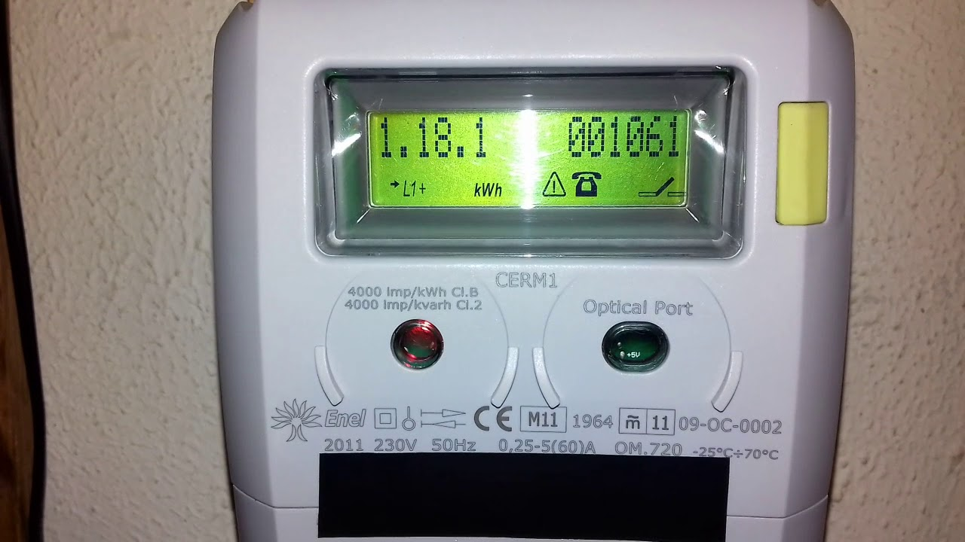

**CHILQUINTA**

Chilquinta, which has a very strong presence in the Valparaiso region, has its own project that started with 5000 users, one of its devices is LIBRA II.

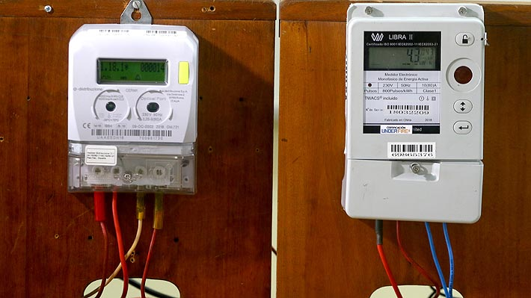

For this same legal vacuum it has been very difficult to obtain information that allows us to obtain more manufacturers, since electronic meters have been certified for more than 8 years but we need to be able to determine which ones are correctly intelligent and that provide the necessary tools to comply with the requirements of intelligent measurement.

**REFERENCES**

<http://www.emb.cl/electroindustria/articulo.mvc?xid=2656>

<https://ciperchile.cl/2019/03/01/instalaran-nuevos-medidores-inteligentes-de-electricidad-el-costo-de-us1-000-millones-sera-asumido-por-clientes/>

<https://www.emol.com/noticias/Economia/2019/03/08/940489/Estudio-de-la-USACH-demuestra-que-medidores-inteligentes-y-antiguos-registran-el-mismo-consumo-de-electricidad.html>

<https://www.electricas.cl/medicioninteligente/>

<https://www.leychile.cl/Navegar?idNorma=1098689>